Mid Term Spring 2015 (BSc. Engg) Industrial Engineering Department, UET, Taxila
(ME 294) Mechanics of Materials
Time Allowed: (8 minutes for MCQs) Max. Marks: 20
(Encircle your Choices) and Solve Question 1 on this sheet and Return to Invigilation Staff after 10 minutes.
Name: ___________________________________ Regd No: ___________________
Question 1(5):
- In Mechanics of Materials, we keep the following assumption/assumptions
- Rigid b) Equilibrium
- Equilibrium and Rigid d) All of the above

- 1 MPa = ..........
- 1 N/m² b) 1kN/mm² c)1 N/mm² d) None of the above

- The symbol for normal strain is ………….
- ɣ b) σ c) τ d) ε

- The thermal stress does not depend on the……………………. of the bar.
- length b) co-efficient of thermal expansion c) modulus of elasticity d) temperature change

- Shear stress acts ……………. to the surface.
- Perpendicular b) Parallel c) both a and b d) None of them

- Many manufacturing operations on metals are performed at stress levels between the …………..and the tensile strength.

- Yield Strength b) UTS c) Fracture strength d) Fatigue strength

- Structures are classified as statically determinate if their reactions and internal forces can be determined solely from
- free-body diagrams b) equations of equilibriums c) equations of compatibility d) Both a and b

- Young’s modulus, E, is the slope of the stress-strain curve ……..the test specimen starts to yield
- before b) after c) both a and b d) None of them
- The strain is uniform upto…………..
a) Yield Strength b) UTS c) Fracture strength d) Fatigue strength
- Factors of safety with respect to the ultimate strength of a material are usually ……… than those based upon yield strength.
- Smaller b) Larger c) same d) None of them

Mid Term Exam (BSc. Engg) Industrial Engineering Department, UET, Taxila
(ME 294) Mechanics of Materials
Part B
Note: No Choice, Assume any data where necessary, Solve Part B on the ANSWER BOOK
Time Allowed: 1:30 minutes
Question No 2 (4):
Determine the total increase of length of a bar of constant cross section (A) hanging vertically and subject to its own weight as the only load. Assume: Length of bar is L , young’ modulus is E and specific weight of bar is ɣ. The elongation of the element of thickness dy shown is 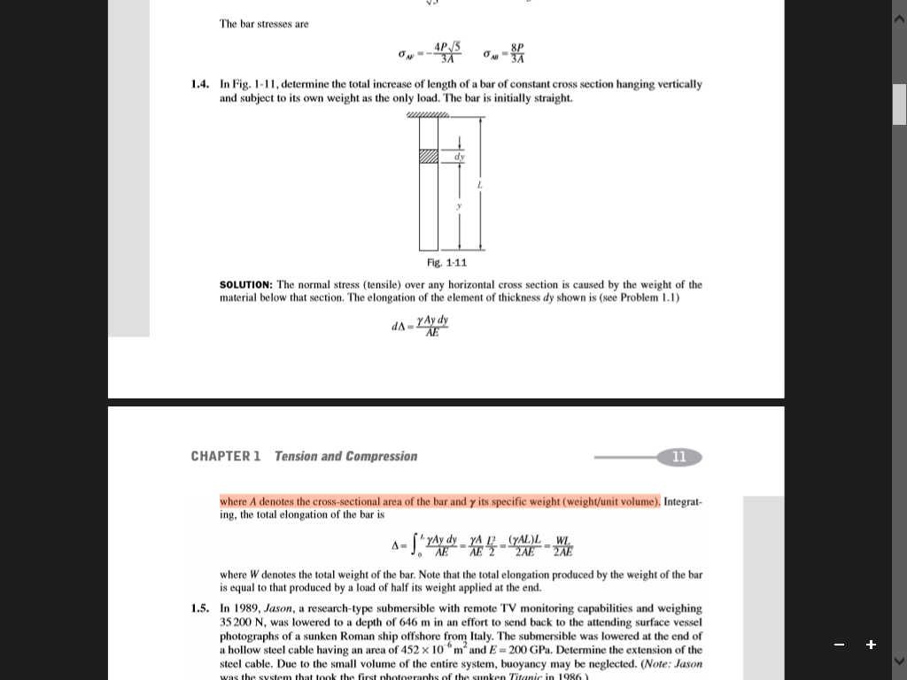 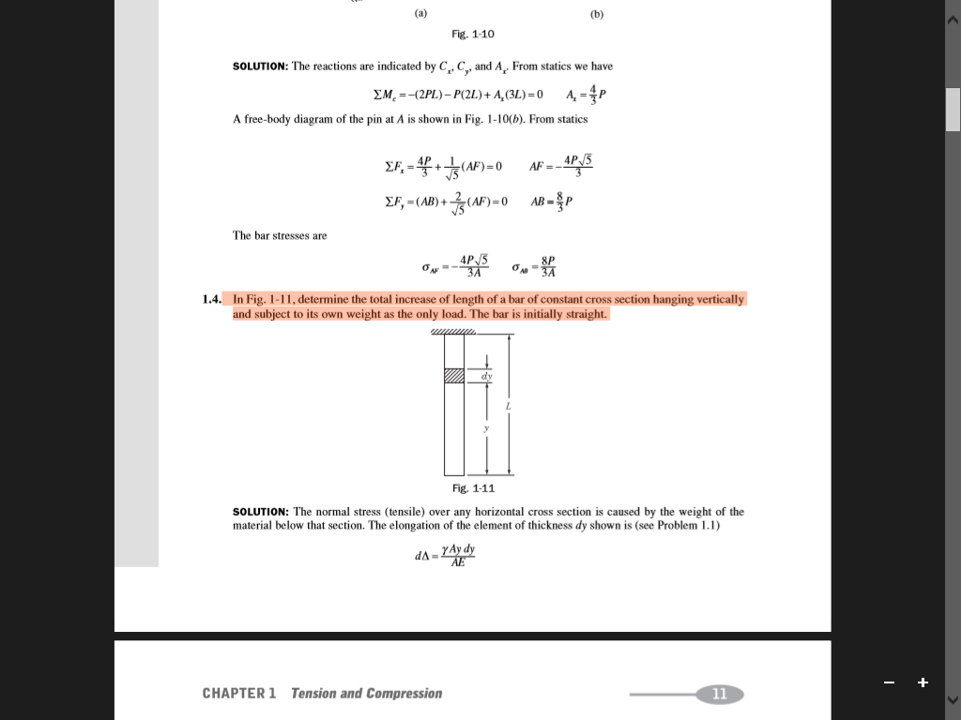 where W denotes the total weight of the bar.

Question No 3 (4):
Define the following:Complementary Shear Stress : A shear stress is always accompanied by a balancing shear stress across the planes at right angles, the balancing stress is called complementary shearing stress. 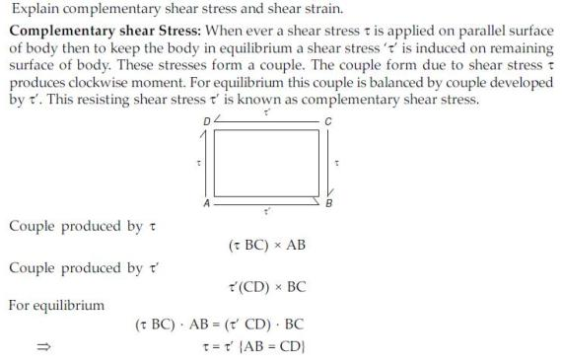
- Bulk Modulus : Bulk Modulus or Volume Modulus of elasticity:It is defined as the ratio of applied pressure (on each face of solid cube) to volumetric strain. It is represented by ‘K’ K = p/ε_{v}
c) Modulus of elasticity: It is the ratio between compressive stress and compressive strain or tensile stress and tensile strain. It is denoted by ‘E’
      - E = stress/stain = σ/ε = σ_{t}/ε_{t} = σ_{c}/ε_{c}
d) Modulus of rigidity: Modulus of rigidity or shear modulus :It is the ratio of shear stress (τ) to shear strain (γ). It is represented by ‘C’, ‘N’ or ‘G’.
      - C, N or G = τ/γ

Question No 4 (3):
A 3 mm thick aluminum sheet is cut with a 4 cm diameter round punch. If the punch exerts a force of 6 kN, what is the shear stress in the sheet?
The area equals the circumference of the circle times the thickness of the sheet metal: A=πdt.
Shear stress τ= P/ A
=P/ πdt= 6kN/π⋅4cm⋅3mm =15.9MPa

Question No 5 (4):
The prismatic bar AB is attached to rigid supports at both ends and is axially loaded by a force P at an intermediate point C. Find the reactions R_{A} and R_{B} .
- These forces cause the bar to change in length by an amount δ _{AB} , which must be equal to zero:

δ _{AB} = 0 ………..(b) This equation, called an equation of compatibility



